1. [20 points] As blood moves through the heart, what is the last valve it passes through before it goes to the lungs?

The right ventricle contracts and ejects the blood out to the pulmonary arteries to the lungs through the pulmonary semilunar valve (pulmonary valve in figure below).

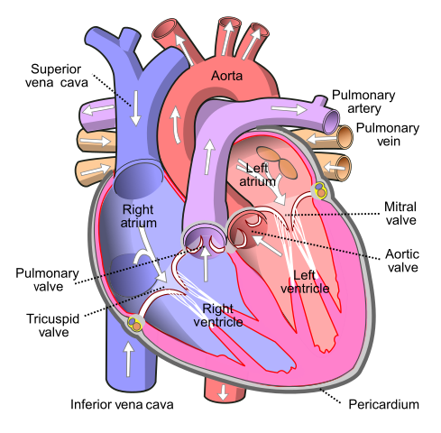

**Fig. 1**: diagram of human heart by Wapcaplet - Own work, CC BY-SA 3.0, <https://commons.wikimedia.org/w/index.php?curid=830253>

1. [20 points] What would be the effect on the Wiggers diagram for the left heart of a reduction in effective cross-sectional area of the aortic valve by a factor of 5 (this sort of reduction in cross-sectional area is referred to as aortic stenosis)? Explain/discuss briefly.

As the cross-sectional area of the aortic valve is greatly reduced, the aortic valve is significantly narrowed, the heart has to work harder to eject blood into the aorta. This results into a big increase in systolic ventricular pressure (represented by the dashed red curve on the figure 2). The narrowed aortic valve also reduces the pressure in the aorta, the magnitude of the ejection fraction of the ventricle is reduced.

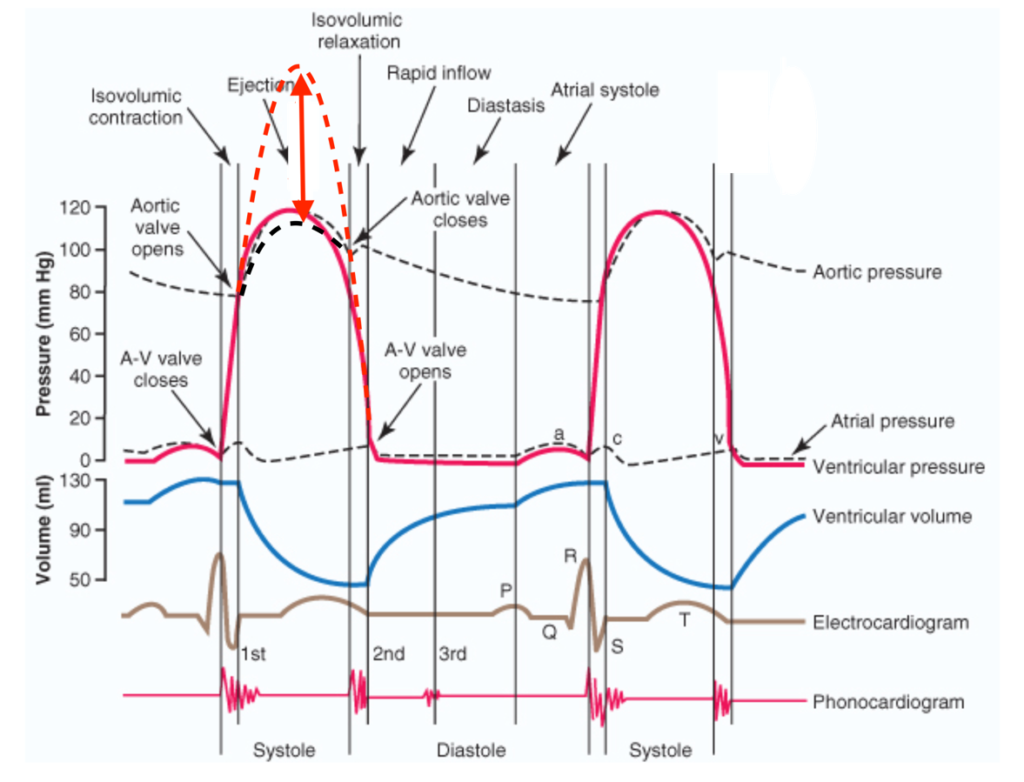

**Fig. 2**: Effects of aortic stenosis on left ventricle and aortic pressures: increased ventricle pressure (dashed red line) and decreased aortic pressure (dashed black line). In vertical red arrow: increased pressure gradient across aortic valve.

1. [20 points] What would be the effect(s) on a left ventricular pressure-volume loop of an increased afterload, assuming preload and ventricular contractility remain the same? Explain/discuss briefly.

The afterload is the aortic pressure against which the ventricle is isovolumic contracting. Assuming preload and ventricular contractility remain constant, if afterload is increased, the ventricle needs to generate a higher pressure to overcome the increased aortic diastolic pressure prolonging the pressure isovolumic contraction phase. The ejection will start at a higher aortic diastolic pressure. Constant preload implies constant end diastolic volume. So the PV loop compared to the “normal” PV loop stretches more vertically along the LV pressure axis. Also compared to the “normal” heart, the end-systolic volume is increased, therefore the stroke volume and stroke work are reduced.

The end-systolic volume is increased due to the increased afterload and reduction of the velocity to which the blood is ejected from the left ventricle resulting in a decreased ejection fraction.

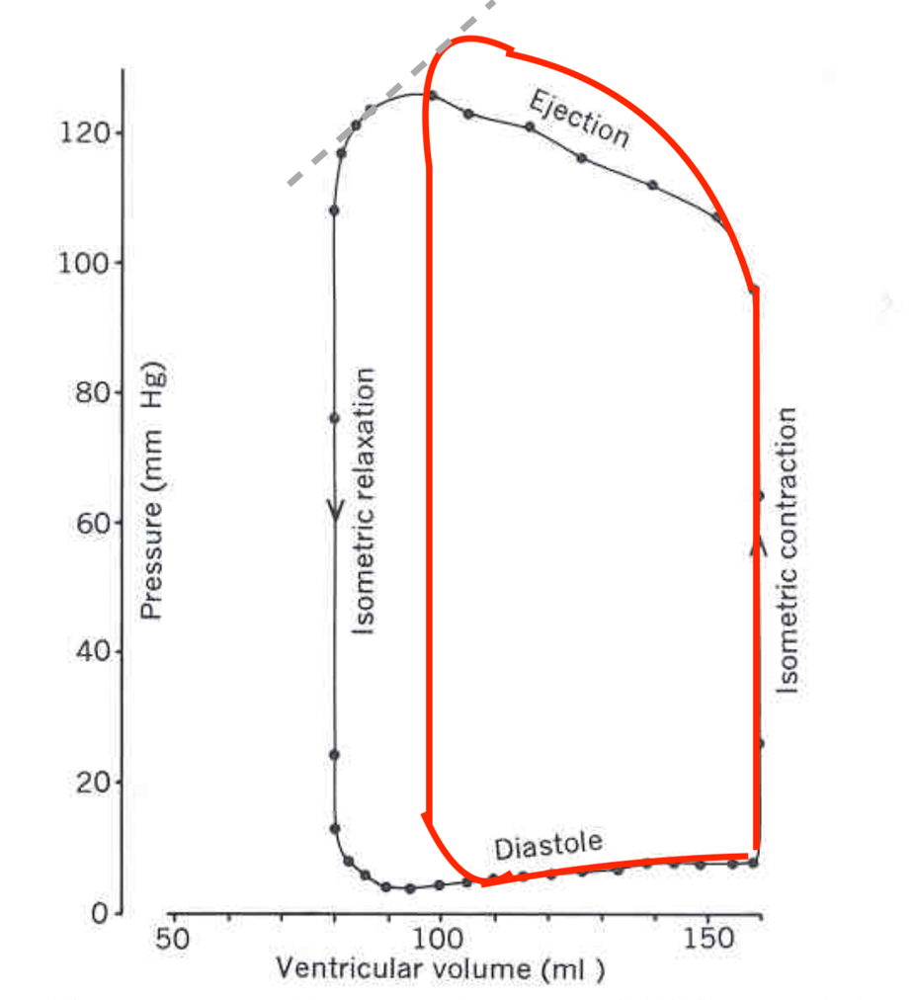

**Fig.3:** PV loop of increased afterload in red compared to “normal” left ventricle when preload and ventricular contractility remain constant (original figure from module 7, video 2, slide 3).